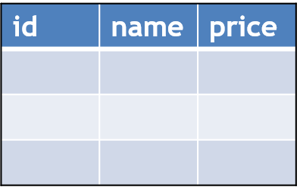sdfsdf11

Columns

Rows

Emp

Id primary key

Not null

Identity true

FillSchema(dataset)

fill(dataset)

("select * from Product",

connection

ConnectionString=“”

con

dataAdapter

dataset

|  |  |  |  |
| --- | --- | --- | --- |
| 122 | LED Light | 90000 | 2 |

DataRow drCurrent = dataset.Tables["emp"].NewRow();

dataset.Tables["emp"].Rows.Add(drCurrent);